Chapter 5: How much mathematics can you eat?

- Introduction

A universal constant amongst all animals is the need to eat. The appreciation of food and drink has been one of the greatest forces moulding our lives both from a point of view of day to day existence, and also our sense of taste and aesthetics. Food truly brings us all together, and without it we would all surely die. The food and drink industry is the largest in the world and in order to feed the growing population of the world we will have to grow more food in the next 50 years than we have in the last 10,000 years.

In this chapter we will look at the role that mathematical models plays in the production, cooking and consumption of food and drink, taking you from ‘farm to fork’ with a series of case studies based on my own experiences. I hope that you will all enjoy this rich diet of mathematics.

- Some basic facts

What does mathematics do to help the starving people in Africa? This is a question I am not infrequently asked when I give talks to schools, where the pupils are not aware of the many applications of maths to the real world. The simple answer to this question, is that mathematics in general, and mathematical models in particular, helps a very great deal, by ensuring that they will be fed. Let us think about the various processes involved. In the case of arable farming this involves planting the seeds, watering them and letting them be pollinated and then grow. It may be also necessary to apply pesticides at some point, and to understand the weather well enough to know when to harvest. Following harvesting the food must be transported to where it is needed. Other types of food, such as cattle, pigs or chicken, must be raised carefully and allowed to grow. Chicken eggs need to be incubated and foodstuffs for the animals need to be delivered on time. Once the animals have been slaughtered for their meat, it is usually refrigerated and stored. This has to be done very carefully to make sure that it is safe, and that the meat will be fresh when it is thawed out. This meat also needs to be delivered to the customer in such a manner that it does not lose its freshness. Once at the consumer the food must be cooked safely, eaten and finally digested. Drinks must also be prepared carefully. Mathematics plays a vital role in ensuring that we have safe water to start with. It helps brewers in controlling the fermentation and production process, and in storing beer to avoid sedimentation. It also, as we shall see, helps to put the bubbles in beer and stout.

Sometimes when I talk about food, I am told off for using mathematics and science on ‘something so trivial’. The government disagrees. As a measure of its importance, agricultural science is listed as one of the UK Government’s Eight Great Technologies in a list published in 2012. The UK agri-food industry alone contributes around £100Bn annually to the economy. As part of this the drink industry contributes £18Bn, with 5 Billion pints of beer drunk per year (which works out as 2 pints per week per head of the population). Food related companies and large online retailers employ mathematicians, sometimes in large numbers. Mathematicians are also in demand well before the food reaches the shop shelves. As an example, mathematicians work at the heart of the chocolate industry. It is hard (for me) to think of a better occupation than being a chocolate mathematician.

- It all starts in a field

Apart from fish (which we will come back to later), most of our food production, whether it is crops or animals, involves a field on a farm (or its close relative and orchard or a vineyard). This leads to the often quoted phrase ‘food from farm to fork’. Whilst it might look on first inspection to be a low technology item, a lot of science and mathematics is involved in making a field effective for food production. Indeed there are sophisticated computer packages which are used to simulate the behaviour of a field and to advise farmers on the best way to manage the fields on their farm. The basic questions that need to be addressed by a farmer growing crops are: what crops to grow and how much, how much to irrigate them, what pesticides should be used, how to react to the weather and when to harvest. The first of these questions involves the mathematics of optimisation. It is perhaps useful to give an idea of how this might work with a simple field (or maybe several fields) on a farm.

Let’s consider an actual example of a farm somewhere in the tropics in which we want to grow two crops, such as cocoa and pineapples. We suppose that c is the amount of cocoa we plan to grow in one year, p is the amount of pineapples, and the unit cost of cocoa seed is a, and of pineapple seed is b. A simple mathematical model of the total cost C of growing the two crops is given by:

C = a c + b p + d.

Here d is the upfront cost we must take on just to use the field in the first place. This incides costs such as the rental for the field, labour, irrigation, pesticides, insurance etc. .

Similarly, when we harvest the crops we might expect a unit return of e on the cocoa, and of p on the pineapples. Thus we might make a profit P given by:

P = e c + f p.

Finally, if the amount of space taken up by a unit cocoa is g and by a unit pineapple is h then the total amount of space S taken up in the field by our two crops is given by:

S = g c + h p.

The problem faced by our farmer is then as follows. They want to grow the right amount of cocoa c and pineapples p which in turn maximises their profit P. But at the same time they must also want to keep the cost C below some maximum C_{max}, (their total available cash) and require that the space taken up is less than the total area of the field given by S_{max}. These two conditions are called constraints. In mathematical terms the problem of maximising the profit becomes:

Maximise: P = e c + f p over all positive values of c and p,

subject to: 0 ≤ C ≤ C_{max} and 0 ≤ S ≤ S_{max} .

The problem of maximising the profit, is a special example of a constrained optimisation problem called a linear programming problem. In the case of our problem above this can be solved by using a graph. Each of the constraints defines a region which is bounded by a straight line. The points which satisfy all of the constraints then lie in a polygonal region which is bounded by these lines. Below we show an example in which the optimal combination of c and p is highlighted. It occurs at the corner of the shaded four sided figure bounded by the axes and the lines defined by the two constraints. The shaded region which satisfies all of the constraints is called the feasible region. The optimal solution which maximises the profit P is given by the ‘corner’ of the feasible region which in turn is given by the intersection of the lines defined by taking equality in each of the constraints, so that we take C = C_{max} and S = S_{max} .

C = C_{max} and S = S_{max}

Feasible region

Figure 1: The optimal solution is found by taking the intersection of the two straight lines defining the constraints.

More generally of course, a farmer will have many more crops, or even animals, to consider, as well as many more constraints, such as labour costs, irrigation costs, etc. as well as considering the resistance of each crop to disease. This leads to more complex problems similar in form to the problem above involving many more variables and constraints.

Not dissimilar problems arise in many other applications, such as in retail and in transport systems. A key feature of the problem above is that it is linear. This follows directly from our very reasonable modelling assumptions, which means that we see c and p and their multiples in it, but not more complicated functions such as c², c³ or c^{p}. We call such a problem a linear constrained optimisation problem.

Remarkably, despite their apparent complexity, there is an algorithm to solve all such linear problems. It is called the Simplex Algorithm, and its invention in 1947 by Dantzig was one of the key developments in mathematical algorithms in the 20th Century. Today countless optimisation problems are solved by the Simplex Algorithm, ranging from farming to some of the most complex problems in economics and scheduling. More information about the Simplex Algorithm can be found in [1] and [2].

Things get a bit more complicated when we have to consider the effects of weather and climate. In Chapter Three we looked at the mathematics behind this complicated subject, but it is obvious (and has been for eternity) that the weather has a huge effect on the productivity of a farm. As an example we can look again at the production of cocoa. In the following two figures we show the total yield of cocoa in Nigeria each year and compare it with the mean [3]

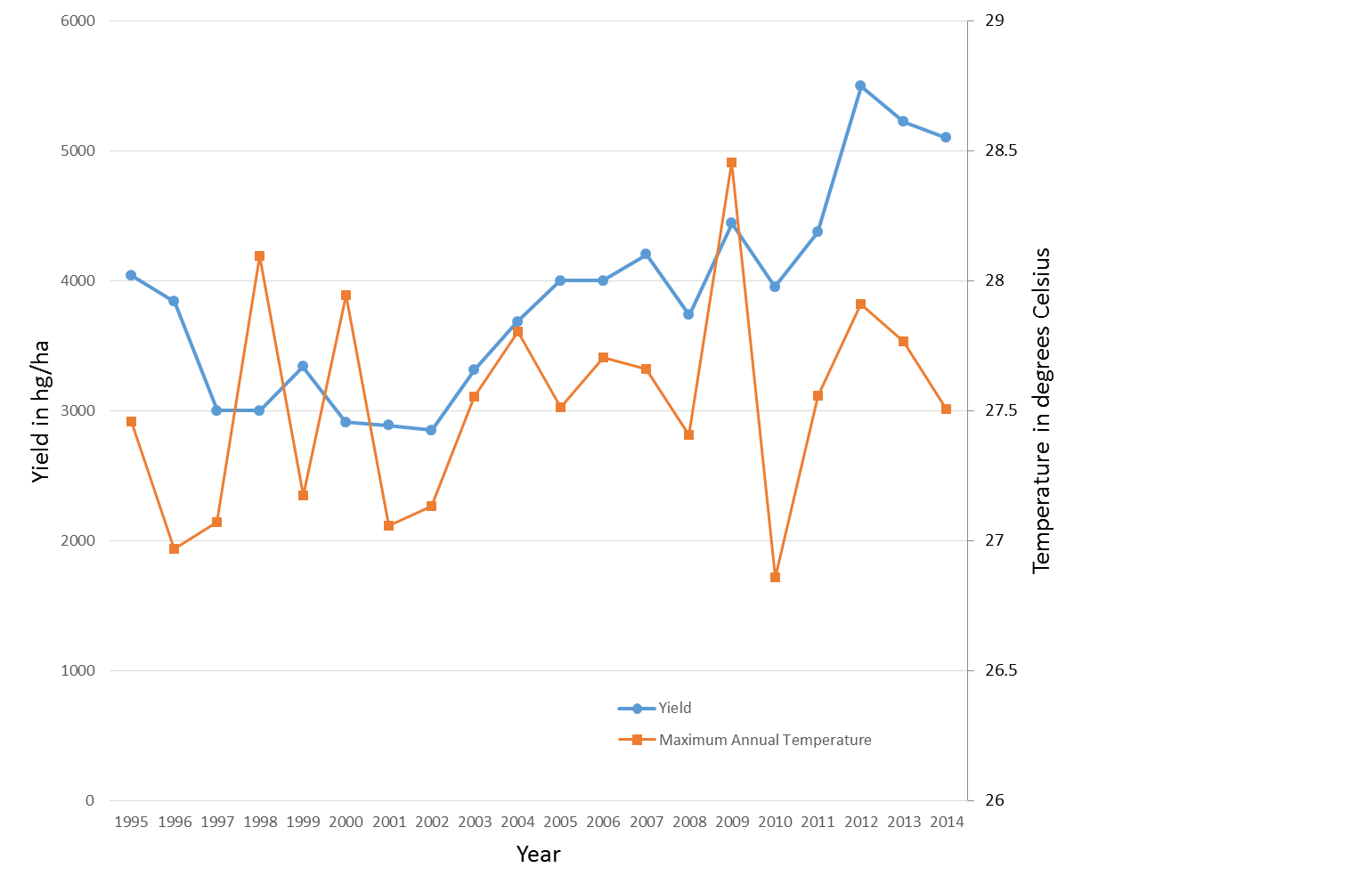
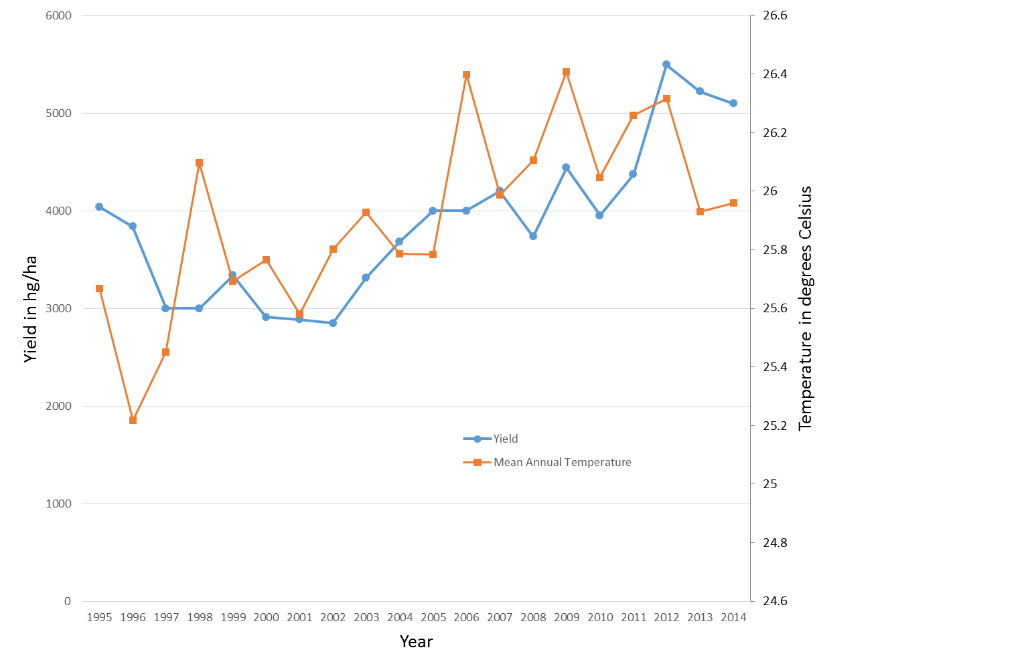

Figure 2. Graphs of rainfall and the Cocoa harvest in Nigeria showing the links. Figures thanks to the Cocoa Research Institute of Nigeria (CRIN).

Farmers must thus plant their crops, taking into account the predicted effects of the weather. In the past this was largely a matter of luck combined with experience. However now it is possible to gain reasonable estimates of what weather to expect by using forecasts based on a combination of statistics and mathematical modelling. Being able to model the potential variation in yields as a result of understanding the weather better enables companies that work with the famers and buy their crops to offer targeted advice to small holder farmers on how to improve their yields, and help secure the development of sustainable farming communities. This work has the potential to make a real difference to the lives of farmers in third world countries

Mathematicians have also considered the growth of crops for the whole of the world. This is important if we are to grow enough to feed the whole of the world’s population. The problem of how things grow, was studied in the classic text by D’Arcy Thompson [4] (now the subject of a major art exhibition in Edinburgh.) If a relatively small amount of a crop is planted and allowed to grow year on year (during which it will be pollinated), then the rate of growth of the crop is proportional to the amount of the crop. We can express this as a differential equation of the form

dc/dt = a(t) c,

where the constant of proportionality a(t) will depend upon factors such as the weather (rain fall, temperature and cloud cover) and the effects of irrigation and of pests. This equation works well if c is small, but as it gets larger, so more resource is needed to grow the crops, and the rate of growth of the crop slows down. Also, when c is large enough we will want to harvest it at a rate proportional to the amount of the crop. These effects is well captured by the so-called logistic equation introduced by Verhulst in 1838:

dc/dt = a(t) c ( k – c ) - b(t) c,

where k is an upper bound for the amount of crops and b(t) is the harvesting rate. This equation can be solved to find the amount c(t) of the crop, and is used to give a very useful prediction of its value if different harvesting strategies are employed and we have good predictions of the future weather.

An equation similar to the logistic equation was originally devised by Malthus to study population growth in human populations and we have already seen a discrete version of it in Chapter 2 when we considered the possibility of chaotic population growth. Such is the power of applied mathematics, that the logistic equation can be used in many other areas related to the supply of food. One of these is fishing, where now c(t) gives the numbers of a fish species, and b(t) a strategy for catching the fish. Extra terms need to be added to allow for the movement of fish into and out of the fishing area, but the basic equation remains the same. See [5] for more details and other extensions to the model. Models for the populations of fish allow managements of fisheries to determine what level of fishing is possible to ensure that there is a sustainable fish population.

I should also point out, that whilst I have considered the role of maths in food production from fields or from the sea, there are other means of producing food which will become $increasingly important as our need for food gets greater. One of these is hydroponics in which$ food is grown on large water bags. Essential to the success of this process are the sciences of fluid mechanics and structural mechanics. Mathematics plays a key role in both. Mathematics is also hugely important in the correct application of fertilisers and insecticides and many other processes.

- How to keep food fresh by freezing it, and then test it for freshness

Once food has been produced it needs to be delivered to where it can be eaten. Usually it is not possible to eat it at once, and it must be stored in such a way that it remains fresh. An early method of doing this was to salt it. However, a major breakthrough came with the widespread introduction of food refrigeration in the 19th and 20th Centuries. Now we take the refrigeration and freezing of food for granted. However, the revolution in cooling and freezing food.was due in no small part to the discovery, and mathematical formulation, of the laws of thermodynamics by Kelvin and others in the 19th Century. These allowed the development of efficient refrigeration devices based upon the expansion of gases.

When freezing food it is important to cool it at the correct rate to ensure that it is uniformly frozen. This requires us to predict both the temperature T of the food, and also the region of the food which is frozen. This is not an easy task. We will start by looking first at the simpler equation of how heat is conducted through a solid body.

  - The heat equation and its solution

The basic model for predicting the temperature of any solid material, including food, is called the heat equation. This equation was discovered by the French mathematician Joseph Fourier (1768-1830) when he considered how heat travelled down a bar of length L, which was initially at a uniform (room temperature) and was then was heated to a high temperature T₁ at one end and cooled to a low temperature of T₀ at the other. This situation is illustrated in the figure below, giving us Step 1 of the modelling process.

Fourier realised that the temperature T(x,t) of the bar depended on time t and position x, and it changed throughout the bar by being conducted through the metal. Provided no part of the bar is frozen then (to short cut steps 2-3 of the modelling process) Fourier found that T satisfies a partial differential equation, the heat equation, which is given by:

Here ρ is the density of the bar, c is its specific heat, and k is the thermal conductivity of the bar, which measures how well it is able to conduct heat.

The heat equation is an example of a partial differential equation. We have already met equations of this form when we looked at the equations governing weather and climate. (Indeed the heat equation itself plays a very important role in our studies of climate as it tells us how heat is conducted through the atmosphere and the oceans.) Such partial differential equations are universal when we look at mathematical models of the real world. In general we cannot solve them mathematically and have to use a computer. It is not easy to solve the heat equation, but unlike the equations of climate it can be solved exactly. Indeed, Fourier came up with a brilliant way to solve it which is now called a Fourier series. Using a Fourier series to solve a hard problem is rather like trying to build a house. Rather than building it in one go, it is much easier to build it brick by brick. The bricks that Fourier used to solve the heat equation were ‘simple’ solutions given by functions of the form

where a and b are arbitrary numbers, and μ and α are related by the formula:

You can check this for yourselves by substituting this solution into the partial differential equation.

These solutions are very special, but Fourier made the astonishing intellectual leap of realising that the general solution of the heat equation could be found by combining an infinite number of these special solutions. If the bar has length L then Fourier considered a general solution of the form:

This rather fearsome expression is now called a Fourier Series. If you look carefully you will see that it is made up of lots of special solutions of the heat equation multiplied by the numbers a_{n} and b_{n}. These numbers are called the Fourier Coefficients. In the case of t=0 then the expression takes the form

Now T(x,0) is the initial temperature of the bar, which we can assume is known. Fourier’s genius was to realise that if you can work out the values of a_{n} and b_{n} for the initial temperature T(x,0) then the Fourier series would allow you to work out the temperature T(x,t) for all future times and locations.

Fourier’s method works not just for the heat equation, but for many other linear partial differential equations. It inspired a whole branch of mathematics now called Fourier Analysis. Not only is Fourier analysis of vital importance in solving partial differential equations, it also has huge applications in most areas of physics and engineering. For example, if we want to reproduce a particular sound then we ‘simply’ have to work out the Fourier coefficients of that sound. Since the discovery of the computer algorithm called the Fast Fourier Transform (FFT) then this can be done very quickly indeed. This process lies at the heart of modern communications revolution.

One application of Fourier Analysis is a formula which allows us to calculate the Fourier coefficients. In particular if the bar goes from x = 0 to x = L we have that:

and if n > 0 then

As an example of how we can use this, imagine a bar which is initially at a room temperature of 20º C so that T(x,0) = 20. The left hand side of this bar is then suddenly raised to 100º C. Following the procedure above we can work out the temperature for all future times. The result is a rather messy infinite series, but we can easily sum it up on a computer. Here is an example of just such a calculation when we take: L = ρ = c = k = 1.

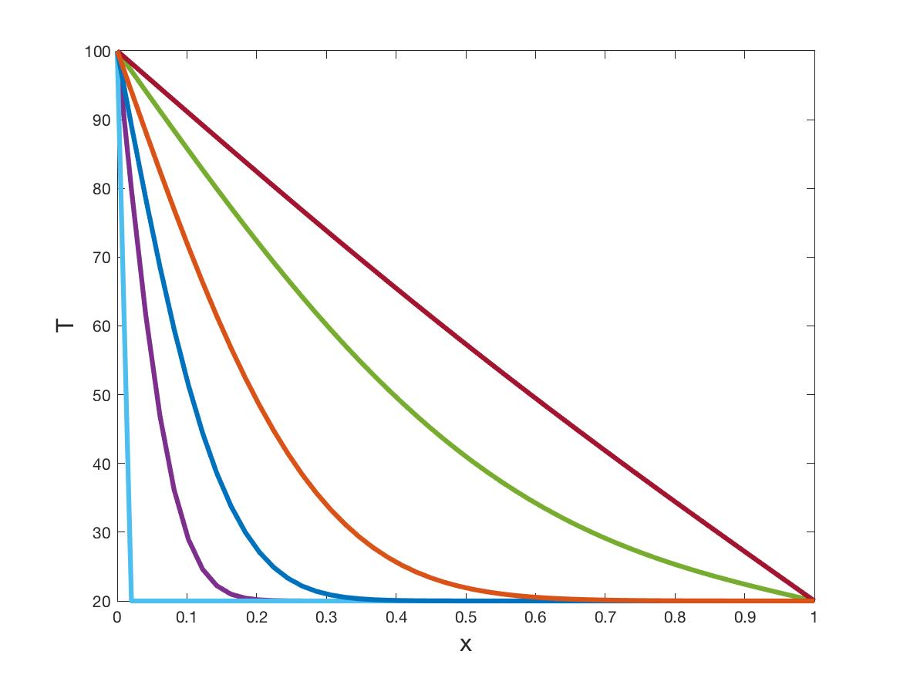

(7)

Figure 3 The temperature of the bar for a set of increasing times. The temperature tends to an equilibrium of a straight line for large times with one end at 100 degrees Centigrade and the other at 20 degrees Centigrade.

In this figure the left most curve is the temperature immediate after the left most point of the bar is raised to 100ºC. You can see that all of the rest of the bar is at 20ºC. The curves then show what happens as the time t increases to t = 0.3. You can see that the ‘heated’ part of the bar increases in length as the time increases. For long times the bar reaches a steady temperature T∞(x) which is given by

T∞(x) = 20 + 80 (1 – x).

4.2 Icy times

If instead of a metal bar we think of a liquid such as water, or a food stuff which is mostly composed of water, then things get much more complicated, and we must extend our previous model. The reason for this is that if water reaches a temperature of 100 degrees Centigrade then it boils and turns to steam (a gas). Similarly when water gets to 0 degrees Centigrade then it freezes and turns to ice. This is called changing the state of the water, or a phase change. Turning water into steam requires extra energy, called the Latent heat. Similarly, is takes the addition of latent heat to turn ice into water. The sum of the heat energy ρc T needed to warm up the water to a temperature T (often called the Sensible Heat) together with the Latent heat at the phase change, is often called the Enthalpy H(T). This idea was invented by the Dutch scientist Heike Onnes in 1909.

To find the temperature of the food stuff, and to allow for the change of state, we must extend our original model. In this extension the heat equation is replaced by the more complicated nonlinear Enthalpy equation:

The Enthalpy equation is hard to solve by hand (the Fourier series method won’t work in this case because the equation is nonlinear). However it is quite easy to solve it on a computer. By solving this equation it is then possible to plan, and control, the freezing process for a wide range of different food-stuffs. In the figure below we show just such a simulation. In this problem a column of water between x = 0 and x = 1, which is initially at room temperature, is kept at room temperature at x = 0, but the end at x = 1 is reduced to -10 degrees Centigrade. It then starts to freeze from the right, with a region of ice growing from the right. In this figure you can see the temperature for an increasing series of times. The edge of the ice is visible as a ‘corner’ in each graph. As time increases, the water tends to an equilibrium in which the region x > 0.7 is all ice.

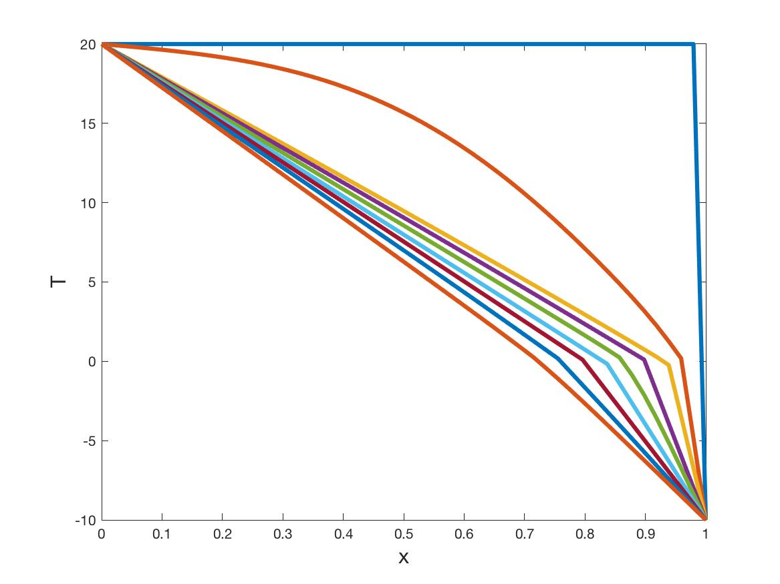

Figure 4 A column of water in which the right hand end is reduced in temperature to -10 degrees, and the left hand maintained at room temperature. The water freezes from the right hand side, finally forming a region of ice occupying the region x > 0.7.

By solving the Enthalpy equation it is possible to predict with high accuracy how rapidly a food stuff will freeze, and how much of it will remain frozen (as we saw in the example above). This knowledge is vital if we want to keep food frozen so that it remains fresh. Once food is frozen it is stored in refrigerated cabinets, rooms, trucks, buildings and warehouse, some of which can be as large as a football pitch. Such storage can bring its own problems. For example, what happens if the door of the warehouse is left open for too long. By calculating the transfer of the heat within the warehouse using the Enthalpy equation, it is possible to provide careful guidance for the safe time that this can happen without the frozen food deteriorating to a point where it is not safe to eat. Such procedures can potentially save huge amounts of food going to waste, and allow it to be stored and transported safely.

  - How fresh is a fish?

One of the more interesting problems that I have ever had to work on was that of finding out how fresh a fish is. When fish are caught at sea they must be brought back to harbour and then sent on to (for example) supermarkets. Clearly such retailers need to know how fresh the fish is.

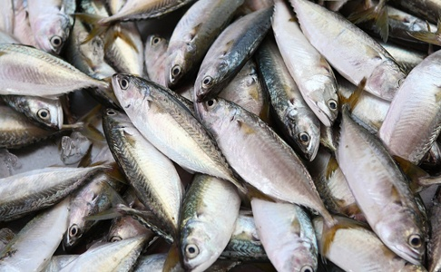

Figure 5. Recently caught fish. But how fresh are they?

We often think that we can test the freshness of a foodstuff by its smell, but often food only starts to smell when it is far from being fresh. So, with fish, a method for testing it had to be used which did not (only) rely on its smell. The method we came up with was to look at the elasticity of the skin, and the viscosity of the flesh beneath the skin. Both are closely related to the freshness. For example our own skin becomes less elastic as we grow older. In order to test this method we produced a mechanical probe to test the elasticity of the fish skin. This probe bounced a small needle off the skin, and then monitored its response. By formulating a mathematical equation for the expected motion of the skin, and comparing this with the measurements of the probe, it was found possible to deduce successfully both the elasticity and the viscosity of the flesh, and hence the freshness of the fish. I will talk more about these equations in some detail in the next chapter about the mathematics of materials.

- Why a bunch of mathematicians couldn’t organise a piss up in a brewery.

In the year 2005 the British Science Festival came to Dublin. At that time I had the honour of being the president of the Maths Section of the British Science Association. Thus august body had the responsibility of devising a mathematics programme for the event. One of our plans was to have a mathematics visit to the Guinness Breweries in Dublin. Obviously there are many reasons why we might want to visit a brewery, but why should mathematicians want to go there, and why should they want to go to Guinness? The answer to both of these questions lies in the person of William Gosset (1876-1937) pictured below.

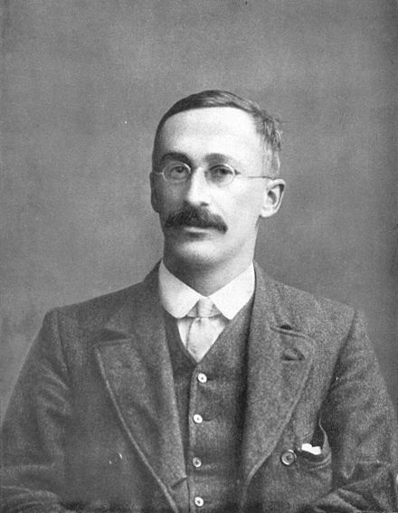

Figure 6. William Gosset, chief statistician for Guinness

William Gosset was the chief statistician at Guinness in the first part of the 20th Century. Guinness was in many ways ahead of its time in the production and quality control that it applied to its product (as well as the way that it was advertised). Gosset was employed in part to ensure that the Guinness stout was of a consistent quality. This was done by making careful measurements of a sample of the product and using these to assess both its general quality and its variability. This was, at the time, a difficult problem in statistics. To solve it Gosset devised a new statistical test to compare the measurements. This worked extremely well and made a very real difference to improving the quality of Guinness Stout. Gosset felt it important to publish this test, but was reluctant to disclose his identity and that of his employer. Instead it was published in the journal Biometrika, in 1908, under the anonymous name of ‘Student’. Ever since this test has been known as Student’s t-test and it plays a central role in testing and maintaining the quality of food and drink all over the world, as well as countless other products.

So, let’s get back to the British Science Festival in 2005. Having decided to go to Guinness we set up a sub-committee to organise the trip to it during the science festival, in part to celebrate the invention there of the t-test, and also its contribution to modern statistics. Clearly such a trip should include a reception and a drink of a pint of Guinness, Unfortunately, through no ones fault, it wasn’t possible in the end to do this. It was only after the event that we realised that we could then be accused of being unable to organise a piss up in a brewery.

- I’m forever blowing bubbles

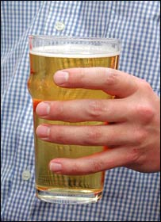

Figure 7. A pint of Lager. Note the relatively small head at the top caused by bubbles of Carbon Dioxide.

We have mentioned Guinness in the previous section. One of the key features of a pint of Guinness is the wonderful creamy foam head. This is in contrast to the much smaller head that we find on a pint of bitter or lager beer. For the manufacturers of beer to get both types of head involve a lot of science and maths. The foam in the head in a pint of bitter is made of networks of bubbles of Carbon Dioxide separated by thin films of the beer itself, with surface tension giving the strength to the thin walls surrounding each bubble. The walls of these bubbles move as a result of surface tension with smaller bubbles moving faster as they have a higher curvature. This results in the smaller bubbles being ‘eaten’ by the larger ones in a process called Oswald ripening. Basically small bubbles shrink and large bubbles grow, leading to a coarse foam made up of large bubbles only. Eventually the liquid drains from the large bubbles and they pop, and the foam disappears.

Foams are very important in many applications, from food and drink, to fighting fires. A lot of effort has gone into devising mathematical models which explain their properties. The remarkable mathematician John von Neumann, who was (amongst many other achievements) responsible for the development of the modern electronic computer, devised an equation in 1952 which explained the patterns that we see in such cellular structures in two dimensions. In 2007 this was extended to three dimensions by a group of mathematicians in Princeton interested in the applications of maths the beer [6]. It’s a hard life!



Figure 8. A pint of Guinness Stout. Note the much thicker, and creamier, head caused by bubbles of Nitrogen.

Another group of mathematicians, appropriately from the University of Limerick in Ireland, have made a study of the foam on a pint of Guinness. This is much creamier than the foam on a pint of bitter. The reason is that whilst the foam on bitter is made up of air bubbles, the foam on a pint of Guinness is made up of Nitrogen. This gas diffuses 100 times slower in air than Carbon Dioxide, meaning that the bubbles are smaller and the foam is much more stable and creamier. The Nitrogen needs to be introduced into the Guinness when it is poured. In a pub this is achieved by having a separate pipe, linked to a Nitrogen supply, which supplied the Nitrogen at the same time as the beer is served from the barrel. For many years Guinness in cans did not have a head. However, this problem was solved by the introduction of a ‘widget’ which is a Nitrogen container in the can, and which releases precisely the right amount of Nitrogen when the can is opened. This process must be very carefully controlled, and a lot of careful design work is required to make the widget work well. The whole process was analysed by using careful mathematical model, derived (it appears!) the whole of the applied mathematics department at Limerick. This mathematical model is escribed in the charmingly titled paper On the initiation of Guinness [7]. Notably the same group has now done a complete analysis of the mathematics of a making coffee.

- Saving the penguins

Which came first, the chicken or the egg? The answer is of course the egg! Think about it in the context of the inheritance of parental characteristics. Maths isn’t needed to solve that question. However, it is important both in the question of hatching an egg and also in helping the chickens, and other birds, to lay the eggs in the first place. The chicken industry is a huge part of the food industry, with an estimated number of 26 Billion chickens in the world in 2020. For chickens to able to lay healthy eggs, they must be healthy too. Keeping them healthy is a matter of giving them a good diet and also a safe environment. Statistical techniques are used extensively to determine good and healthy diets for all animals, and also to monitor how they respond to their environment, so that it is never too hot or too cold. (These tests are not unlike the clinical trials used by pharmaceutical companies to test drugs before they are released.) Now consider what happens when an egg is laid. If we want to breed more chickens these eggs need to be incubated, and it is most efficient (in the case of large numbers) to use an incubator to do this. Such incubators have to carefully regulate their heat and humidity. Sophisticated incubators also rotate the eggs during the incubation process and it is natural to ask the question of what is the best way to rotate the eggs. To answer this question we need to devise a mathematical model of the incubation process.

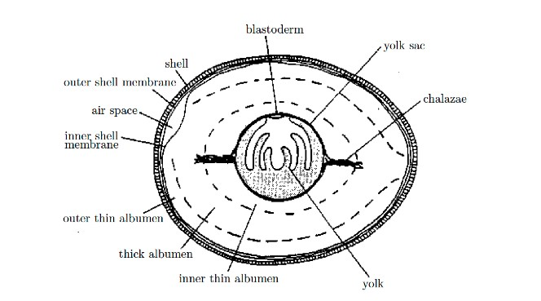

Figure 9. A cross-section through a typical penguin egg.

I was part of a team of mathematicians in the European Study Group with Industry in 2003 which was asked to do exactly this, not by a chicken farm, but by the penguin house at Bristol Zoo Gardens. The managers of the penguin house wanted to determine the optimal incubation process, and in particular the best way rotate the eggs laid by a penguin. Unfortunately, the reason that we were asked to help was the fact that the zoo was finding that too many of the eggs in the incubator were dying. During a natural incubation process a (male or female penguin as both are involved) sits on the egg to keep it warm, and rotates it at the same time. In the case of natural incubation the egg is rotated about once every 20 minutes.

One theory behind the need for such a rotation was that it was needed to ensure that the heat (from the penguin) was uniformly distributed.

We decided to test this theory by constructing a mathematical model of the heating process of a penguin egg.

As before we can go through the essential steps described in Chapter One, with the basic situation illustrated below:

Figure 10. A schematic of the heating of a penguin egg.

The basic physics is that the penguin sits on a part of the outside of the egg. The heat from the penguin is then transferred to the inside of the egg, which then starts to heat up. The rest of the egg shell acts an insulator, preventing (or at least significantly slowing down) the heat in the inside of the egg from leaking out into the atmosphere. The material in inside of the egg then acts as a conductor of heat, in the same way as the metal bar did in the previous example.

In this case it is possible to use the same heat equation as was used to allow us to predict the flow of heat within the penguin egg. (We don’t have to use the more sophisticated Enthalpy equation as the penguin egg never experiences a change of state. If it did then the penguin embryo would die.) The only difference is that the thermal conductivity, and the heat capacity of this material are different from that of a metal bar. These numbers are all known, or can be easily measured in an experiment.

Because the egg is three dimensional (indeed approximately spherical) then the temperature T is a function of the three spatial variables (x,y,z) and also of time t. In the interior of the egg we then have the three dimensional heat equation which is given by

On the part of the egg in contact with the penguin we take T = T₀ = normal penguin temperature, and on the rest of the egg we take the normal derivative ∂T/∂n = 0.

This equation is hard (though not impossible) to solve analytically (you use a three dimensional version of a Fourier series). However it can be easily solved numerically on a computer by using a finite difference or a finite element method.

The pictures below show the results of using such a numerical method to calculate the interior temperature of the egg at a set of increasing times from left to right given by 1 minute, 5 minutes, and 10 minutes. In these pictures the penguin is at the top, the brown areas are the hottest parts of the egg, and the blue areas are the coolest.

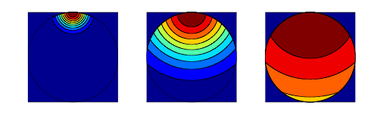
Figure 11. The interior temperature of the egg (brown hottest and blue coolest) at (from left to right) times t = 1 minute, t = 5 minutes and t = 10 minutes.

As you can see the heat from the penguin spreads through the egg and eventually warms it all up. For the particular case of a penguin egg we could calculate that this took about 10 minutes. So ten minutes after sitting on the egg, it has reached a nearly uniform temperature, and at 20 minutes the temperature is a completely uniform, penguin bottom temperature.

In other words, there is no need to rotate the egg at 20 minutes to give it a uniform temperature, as it is already at a uniform temperature.

Thus the simple mathematical model was useful in dismissing an incorrect theory for why the penguin rotates the egg.

Further studies of why the egg had to be rotated needed a much more sophisticated mathematical model. This model looked at the different types of fluid inside the egg, the difference between the yolk and the albumen, and the various chemical and biological process that go on inside the egg. These models showed that the egg needed to be rotated to both redistribute the nutrients inside it and also to get rid of the waste products. Guided by this a better rotation strategy was devised. This strategy led to an increase in the number of eggs that hatched into live penguins. More information about not only the penguin egg problem, but also more about the process of mathematical modelling can be found in the book [8].

- Cooking food in a microwave cooker.

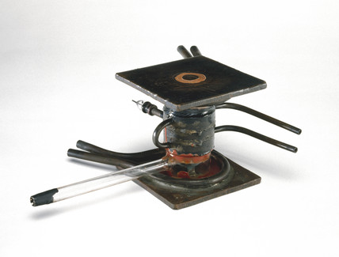

Figure 12. An early cavity magnetron. These were used in radar sets in the second world war. Magnetrons are now used to produce the microwaves used in a microwave cooker.

Before we eat food it is usual to cook it. This is one huge difference between humans and other animals. In fact evidence for cooking food goes back a long way, including evidence that our evolutionary predecessors Homo Erectus were cooking food over 400,000 years ago. Of course cooking then was done over an open fire. Nowadays it is more likely that we will use some kind of cooker. Until recently, most cookers were based on heating the food directly, such as in a fan oven, which cooks the food from the outside by conduction of heat into the food. This process cooks the food uniformly, but can be slow. For example it takes about an hour to bake a potato in a typical fan oven. Many of us now seek a more convenient and faster means of cooking, and this has led to the rise of the use of the microwave cooker. The microwave cooker uses a technology which goes back to the war and the invention of radar. In order to get a high resolution (particularly for airborne radar), radar systems needed to use radio waves, called Microwaves, with a wavelength of the order of just a few centimetres. However, in 1940 there was no means of producing radio signals at this wavelength in sufficient power to be effective. Fortunately the University of Birmingham came to the rescue in the shape of the physics department led by Prof. Oliphant. Working in this department were Randall and Boot who invented the first high power cavity magnetron pictured in Figure 12. This device used a high magnetic field to spin an electron beam and to cause it to resonate in a specially designed cavity. The result was a method of producing high power radio waves of kilowatt power and at Centimetre wavelengths. The magnetron revolutionised radar and was subsequently used in all airborne interception radars and also in the H2S air to surface radar used in Lancaster bombers, as well as in the radars used against U-Boats. It was truly a war winning invention (and was part of a package of secrets taken to the USA by the scientific Civil Servant Sir Henry Tizard as part of the process of persuading them to join in the war). The Americans rapidly developed the technology for producing magnetrons in large numbers. One of the scientists who did this was Percy Spencer, and he is credited with the invention of the microwave cooker. Legend has it that he did this after noticing that his candy melted when exposed to high power microwave radiation, and he realised that the same radiation could be used to rapidly cook food. Now microwave ovens, all powered by magnetrons, are very widely used in a domestic environment. We are all used to opening up a microwave cooker, putting in some food, pressing the button, and ping, five minutes later the food is cooked. Usually these ovens have a turntable, and you can occupy yourself in those five minutes by watching the food go round. Mathematical modelling is very useful not only in understanding this process, but in helping to devise better and safer microwave cookers. This was a task that I was set by the Chipping Campden Food Research Association (CCFRA).

As always we will start Step One of the mathematical modelling process by considering the basic process of what goes on in a microwave cooker. A commonly held view is that a microwave cooker cooks food from the inside out. However, this is not really true, as we shall see. A typical such cooker (indeed the one that we used in our experiments at CCFRA) is illustrated below (together with a set of temperature sensing probes).

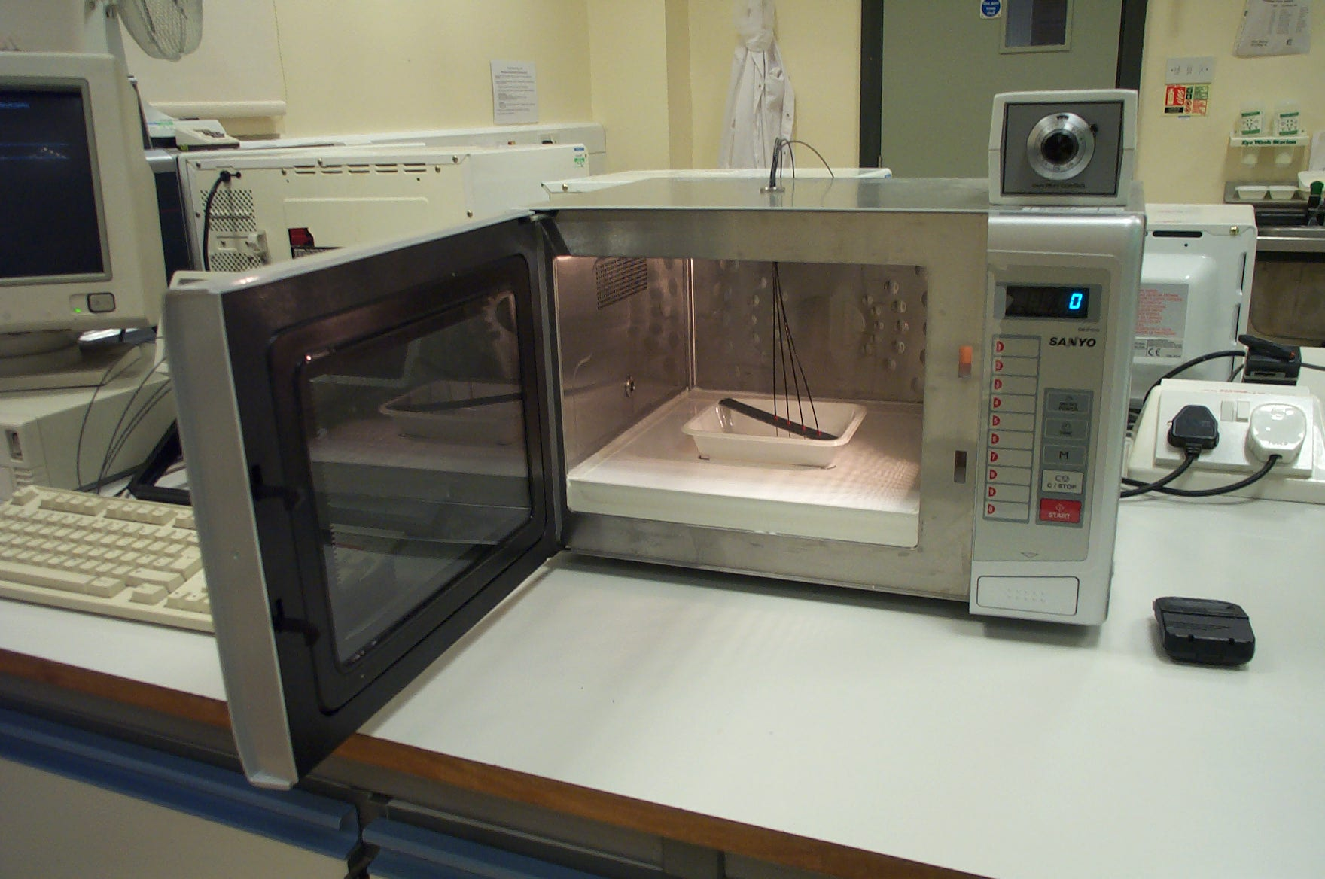

Figure 13. A typical microwave cooker. This was the cooker that we used for our experiments. You can see the tub in the middle where the food was placed, and the temperature sensing probes.

The magnetron generates the microwaves for the cooker. Typically these magnetrons have a total power of around 800W. The microwaves produced by the magnetron are rapidly oscillating electromagnetic fields with a very high frequency of around 2.45 GHz and a wavelength of 12.24 cm. The microwaves then enter the large cavity in the middle of the cooker where they set up standing wave patterns in the electromagnetic field in the cavity. These standing wave patterns give points with a strong microwave fields alternating with points with a low field. To show these points you are warmly recommended to try out the following experiment. Take out the turntable and place several marshmallows in the cavity. Then turn on the microwave oven for a short time. You will find that some of the marshmallows have melted and others have not. The melted ones are at the locations of the anti-nodes of the microwave field, which are the points where it is strongest. As an added bonus you can find the half wavelength λ/2 of the field by measuring the distance between the melted marshmallows. Typically, as we said above if the frequency is 2.45 GHz then λ = 12.24 cm. You can now check this directly using the power or the marshmallow!

The nodes of the microwave field are where it is weakest. If the food is placed in one of these then it would hardly be cooked (this would be a cold spot in the food). The reason that the food is placed onto a rotating turntable is to make sure that it is constantly moving, so that no part of it is always at a node of the field.

During the cooking process, the microwaves from the cavity enter the food and start to heat it up. The way this happens is that the very high frequency microwaves cause the water molecules in the food to oscillate at the same frequency. They then rub against each other and warm up the rest of the food by friction. This transfers energy from the microwaves to the food, heating the food up in the process. As they do so, the microwaves rapidly rapidly lose their strength. This process works very well for water, and hardly at all for ice. So microwave cookers are great for heating up moist foods, but are poor at defrosting frozen foods.

We will now do some mathematics to explain how the field reduces as the microwaves penetrate the food. Key to this is what is called Lambert’s Law. This says that if E₀ is the average strength of the microwave field on the surface of the food, then at a distance x into the food, the average strength E(x) of the field inside the food is given by the formula

$$E\left(x\right)= E_{0} e^{-x/d}$$

Here d is called the penetration depth of the microwaves. The value of d depends on the type of the food, how moist it is, and also its salt content. For a typical food, such as a potato (which is mainly starch and water) the penetration depth is between one and two centimetres. What this means is that the microwaves cannot penetrate much more than two centimetres into the food.

Now, the heating power of the microwave food is proportional to the square of the amplitude of the microwave field which is given by E(x)² . We saw a very similar expression for power in terms of voltage in the last chapter. This power is negligible for fields at depths x much greater than the penetration depth. Therefore the microwaves produce heat within the food upto, but not much deeper than, the penetration depth. Heat is then mainly lost on the surface of the food, mostly by convection through the air but also due to radiation. Because of this the temperature of food heated in a microwave oven initially rises as you go in from the surface, and then starts to fall after you have gone in further than the penetration depth. So the best way to describe microwave cooking is that the food is cooked from about 1 cm underneath its surface. There is an important consequence to this. If the food is much more than a centimetre or two in depth, then the inside of it may receive very little direct heating from the microwave field at all. Therefore if the food is only placed into the microwave cooker for a short time, the inside does not get heated to a high temperature, and bacteria in the food may not get killed. This means that the food may then be unsafe to eat.

Now let us think about how we will model the microwave cooking process. We will use the same heat equation that Fourier devised to find the temperature of the heated bar, but with the very important difference that we will now include a term which models the heat generated by the microwaves. The power P(x) that the microwaves supply to heat the food at the point x is then given by

P(x) = μ E(x)²

where the value of μ depends upon the type of food and how much water it contains. (This number has to be found in advance by experiment). Using the expression for E(x) given by Lambert’s law we can deduce that

P(x) = μ E₀² e^{-2x/d} .

Combining this with Fourier’s heat equation we arrive at our model for the temperature T(x,t) which is given by the following partial differential equation:

c ρ T_{t} = k T_{xx} + μ E₀² e^{-2x/d} .

To use this equation to predict the food temperature we must estimate the average electrical field E₀ on the surface of the food, which we can calculate once we know the power of the magnetron. We also need to know the way that heat is lost on the surface of the food, and this will mean knowing what sort of packaging the food is in. We also need to account for the shape of the food. Typically a microwaved meal comes in the a rectangular container, so it is a fairly uniform shape. The formula above is then applied to each of the sides of the food in turn.

The five figures below taken from [7] show the results of solving this equation to find the temperature of a rectangular plastic container filled with mashed potato, which is mostly made up of moist starch. This simulation is achieved by solving partial differential equations, which describe how the potato is heated. In fact, to allow for the possibility that the moisture in the starch may reach the boiling point of 100 degrees Centigrade and turn to vapour (which then escapes through the food) the heat equation above must be extended to a form of the enthalpy equation which takes the form:

H_{t} = k T_{xx} + μ E₀² e^{-2x/d} .

The figures are all created from solving the enthalpy equation above on a computer with the correct values for all of the terms. (The calculations were done by my PhD student Andrew Hill.) The top shows the results of heating for one minute and the bottom of heating for five minutes. In these figures blue is cold and brown is warm. In this simulation we show the temperature through a cross section of the rectangular container. This is mainly exposed to the microwaves from the top and the bottom, and it has thermally insulating walls. Heat is mainly lost to the air at the top and the bottom. The dimensions of the rectangular container are all expressed in metres.

Figure 14. A cross section through a rectangular container containing moist starch heated in a microwave cooker. The plots show the temperature of the starch modelled by solving the enthalpy equation with the addition of the source term for the power from the microwaves.
See [9] for more details.

You can see from these figures that in the first few minutes the walls of the food are hot. We would feel this if we tried to list the food out of the cooker. However, this would be deceptive, as the inside of the food is still quite cool. Only after five minutes is the food uniformly hot, and this is due mainly to conductance of the temperature within the food evening the temperature up.

Of course, as part of the modelling process that I have described, we needed to check the results of our mathematical model against experiment. To do this we put temperature probes into the food at a series of four points, with the first probe nearest the outside and the fourth nearest to the centre. You can see these if you look carefully at the microwave cooker in Figure 13. We then ran five different trials of heating the moist starch in the microwave cooker, and measure the temperature each time. The results of doing this are shown below in solid blue, with the predictions of the model in dashed red. You can see that these are in good agreement, including the phase change when the temperature reaches 100 degrees. See [9] for more details both of the model and of the experiments that were made to test it

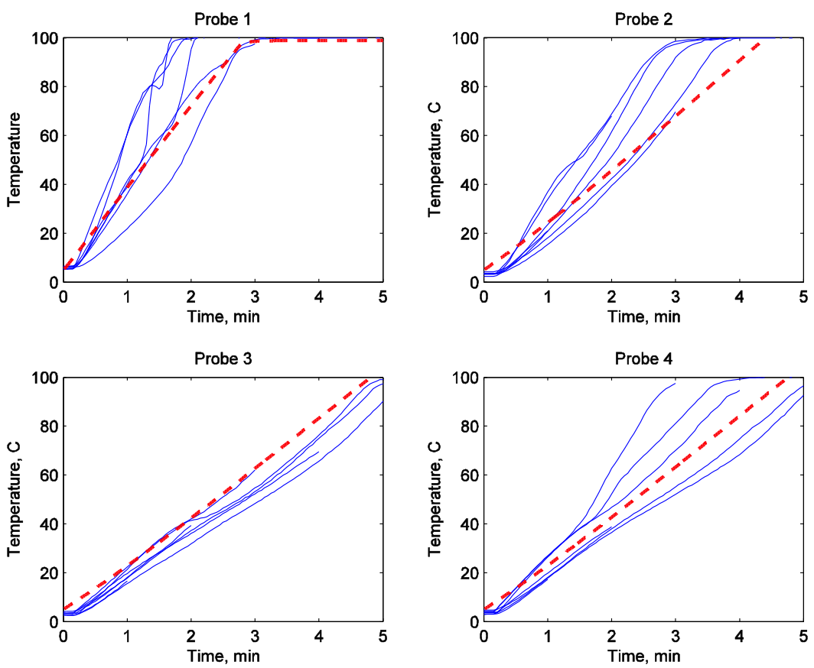

Figure 15. A series of temperature measurements of the microwave heating experiment taken from different probes within the moist starch. The experimental measurements are shown in solid blue, and the predictions of the model in dashed red. See [9] for more details.

The conclusion from the simple model simulation that we might draw is that the best way to be sure that your food is warm all over when you use a microwave cooker to cook it for a long time, and then wait until the middle warms up by heat conduction. However, such long cooking times can damage, and even burn, the outside of the food which is most heated by the microwaves. An alternative method is to heat the food for a while, to then stir it to give it a more uniform temperature, and to then heat it up again. If you read the packet of any microwave cook able meal this is exactly what it says that you should do. Now we can see from our mathematical model why this is sound advice.

More sophisticated mathematical equations can be used to simulate more of the processes involved in microwave cooking and can thus be used to design better, more efficient and safer cookers. This brings great benefits to us all.

9. Packing and distributing

Once we have produced food we need to pack it and distribute it. Both of these processes involve the mathematics of optimisation and scheduling. Food needs to be transported around in such a way that it arrives at the correct place, at the correct time, and is fresh when it arrives. This introduces huge logistical challenges, made worse by the fact that different foods have different shapes, weights and times of delivery. We often forget how much planning is needed to (for example) deliver fresh strawberries to our plate in the middle of winter. These problems are very hard to solve. A classical example being the travelling salesman problem, which aims to find the optimal route for a salesman to deliver his goods.
Another example is the knapsack problem which tries to find the best way to fit a set of differently shaped objects into a knapsack, with direct application to the problem of fitting food into a freezer lorry (illustrated) or a transport plane. Only relatively recently have efficient (probabilistic based) algorithms been developed to provide an answer. These algorithms are now making a huge difference to the way that goods are transported all over the world. To solve this problem uses the mathematical ideas of operational research, and the great subject of mathematical algorithms.

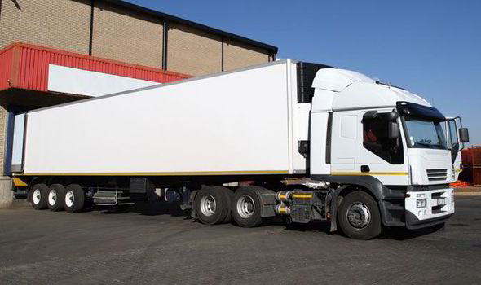

Figure 16. A typical freezer lorry used to transport food.

- In conclusion: Three mathematicians go into a pub.

I will finish this chapter with a bad joke about mathematicians and drinking. You have to concentrate a bit to get the joke.

Three mathematicians go into a pub and the bar tender asks ‘Does anyone want a lager’.

The first mathematician pauses for thought, and then says, ‘I don't know’.
The second mathematician likewise says, ‘I don't know’.
Finally the third mathematician says, ‘No!’

So the bar tender asks ‘Does everyone want a bitter then?’

The first mathematician pauses for thought, and then again says, ‘I don't know’.
The second mathematician likewise says, ‘I don't know’.
Finally the third mathematician says, ‘Yes!’

So they all have a bitter!

Now, think about the mathematical logic contained within this joke as you ponder the rest of the points in this chapter and consider the very real contribution that mathematics makes to feeding the whole of the world

11. References

[1] D. Luenberger, Linear and nonlinear programming, (2008), Springer.

[2] The Wikipedia article on the Simplex Algorithm is given by:
https://en.wikipedia.org/wiki/Simplex_algorithm

[3] See the report on the 2017 KTN workshop at the University of Bath on Agri-Science.
http://www.bath.ac.uk/imi/news/Agri-Food.html

[4] D’Arcy Thompson, On Growth and Form, 1917, Cambridge.

[5] https://en.wikipedia.org/wiki/Population_dynamics_of_fisheries

[6] http://news.bbc.co.uk/1/hi/sci/tech/6592693.stm

[7] The work of the Limerick based MACSI group on Guinness is described in the article
http://ulsites.ul.ie/macsi/sites/default/files/macsi_the_initiation_of_guinness.pdf

[8] S. Howison Practical Applied Mathematics: Modelling, Analysis, Approximation, (2005), Cambridge.

[9] C. Budd and A. Hill, A comparison of models and methods for simulating the microwave heating of moist foodstuffs, Int. J. Heat and Mass Transfer, (2011), 31, pp. 807—817.

